**Terrorism Analysis and Insights**

Date : 10/09/2020

By: BIKI DEY

Guided By:

Forsk Technologies Team

TABLE OF CONTENTS

*1. Introduction*

*2. Related Work*

*3. My work*

*4. Implementation*

*5. Results*

*6. Conclusion*

*7. Acknowledgements*

8. References

9. Biography

# **Introduction**

* **Terrorism Analysis with Insights is a project which consists of a map and graphical representation of all the terrorism related data displayed in a Web Application, which will be used by the client to visualize and analyse data so that some prediction can be made from the given data.**
* **The map can be filtered by range of Years , Month , Date , Region, Country , State , City , Attack type . The chart can be filtered by Region Attacked , Terrorist Organization , Target Nationality , Country Attacked, Target type , Weapon type , Type of attack.**

# 

# 

# **Related Work**

* **Data visualization is the graphical representation of information and data.**
* **By using visual elements like charts, graphs, and maps. data visualization tools provide an accessible way to see and understand trends, outliers, and patterns in data.**
* **In the world of Big Data, data visualization tools and technologies are essential to analyze massive amounts of information and make data-driven decisions.**
* **Our eyes are drawn to colors and patterns. We can quickly identify red from blue, square from circle.**
* **When we see a chart, we quickly see trends and outliers. If we can see something, we internalize it quickly. It’s storytelling with a purpose.**
* **If you’ve ever stared at a massive spreadsheet of data and couldn’t see a trend, you know how much more effective a visualization can be.**
* **So in this project, In order to get a proper visualization output, we had used Dash Python library for filtration of Data and along with that Html & CSS(Cascading Style Sheets) for Creating User friendly UI.**

**MY WORK**

*Requirements:*

*● Dash tool*

*● Python Script*

*● HTML*

*● CSS*

*● Library: pandas*

*According to the client requirement I used dash tool over the*

*python script .*

*⮚ Agile methodology is used to create this project.*

*⮚ I have used the concept of tabs to show Map tool*

*and chart tool according to the users requirement.*

*⮚ I have used Dropdowns to filter the data and to show*

*points and line over the map and chart respectively.*

*⮚ To handle the dropdown values I’ve implemented the*

*concept of callback.*

*⮚ I used open-street-map to display the map with*

*legend set to attack type .*

*⮚ When the page loads by default the map displays all*

*the points with respect to attack type over the full*

*length of the year slider(all values in the dataset) .*

*⮚ For India map tab I’ve set the default value of region*

*and country to ‘South Asia’ and ‘India respectively.So*

*that I am able to give insights over India .*

*⮚ For chart tool I have used a single dropdown to select*

*the category and a search filter based on the selected*

*group along with a year slider.*

*⮚ When the world chart tab loads ,the values of the*

*dropdown is set to region with a empty search filter*

*,chart is displaying the stacked line frequency image*

*of the region .*

*⮚ For India Chart tab the default values for region and*

*country are set to South Asia and India*

*respectively,keeping all other functions as it is.*

Here is my Github Link. :

<https://github.com/Biki721/Client_Project.git>

**Implementation**

I have used Sublime text editor to write the program and used anaconda prompt to run the python script.

* First we need to import the the libraries that are 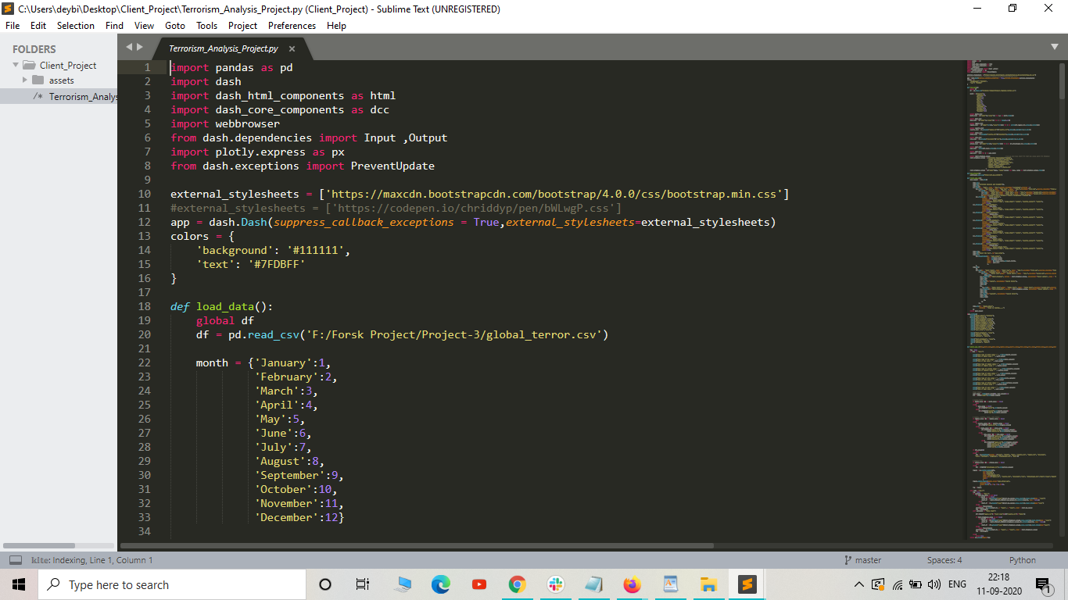needed for the project .
* After that I have created app ui function where html and dcc components are there to build the project with tabs ,dropdown, slider etc.

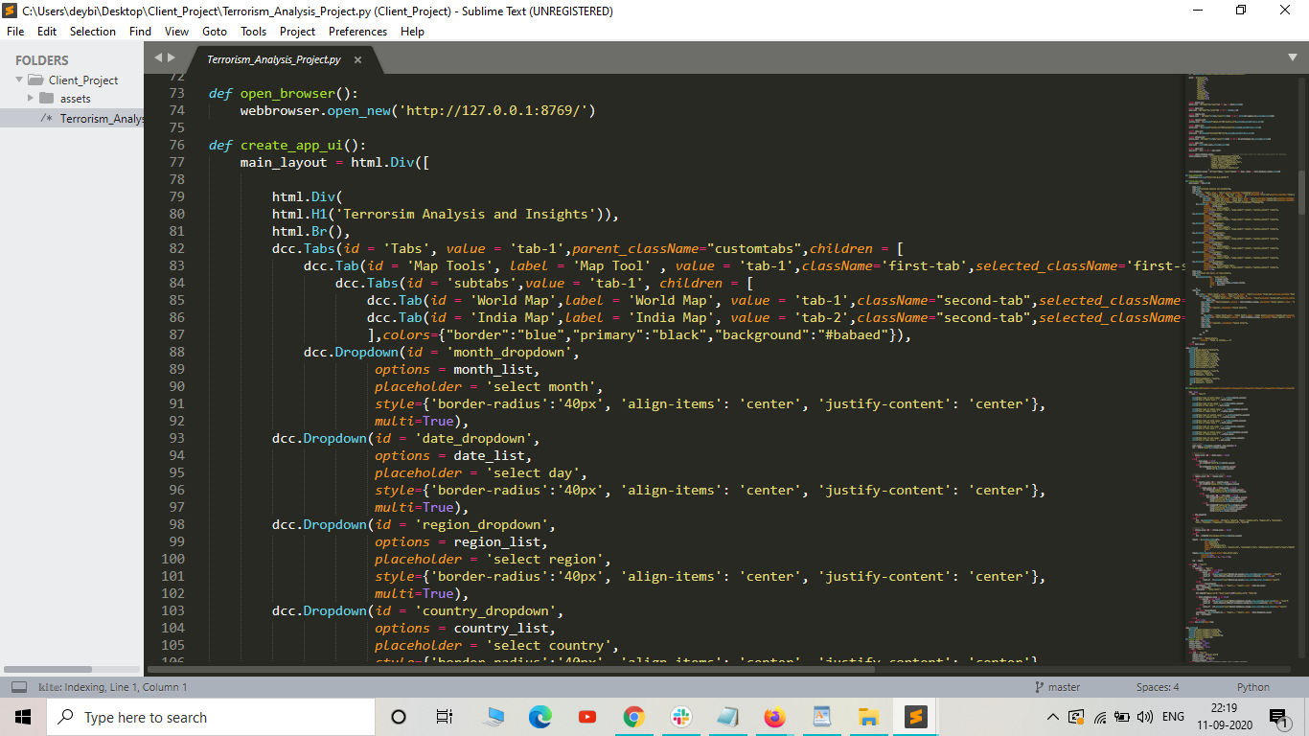

**Results**

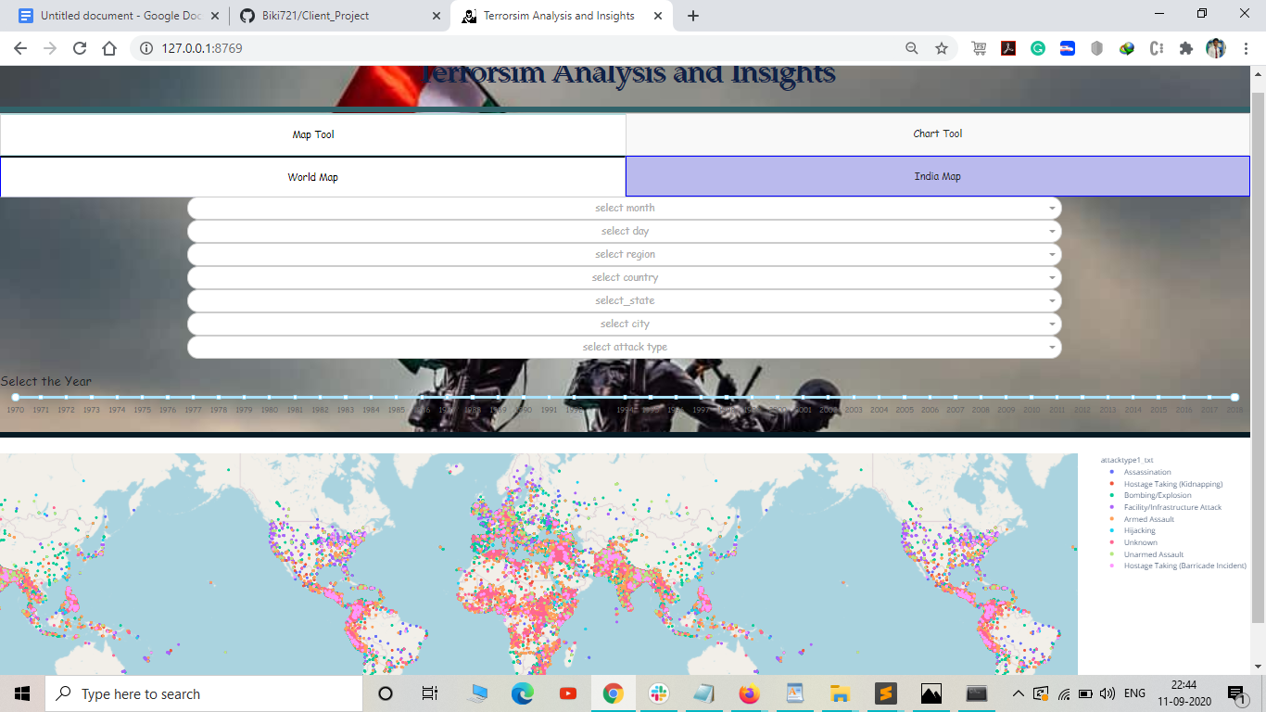

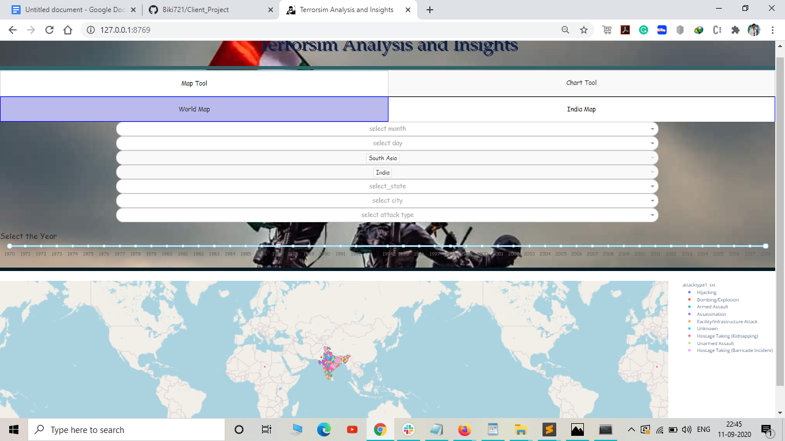

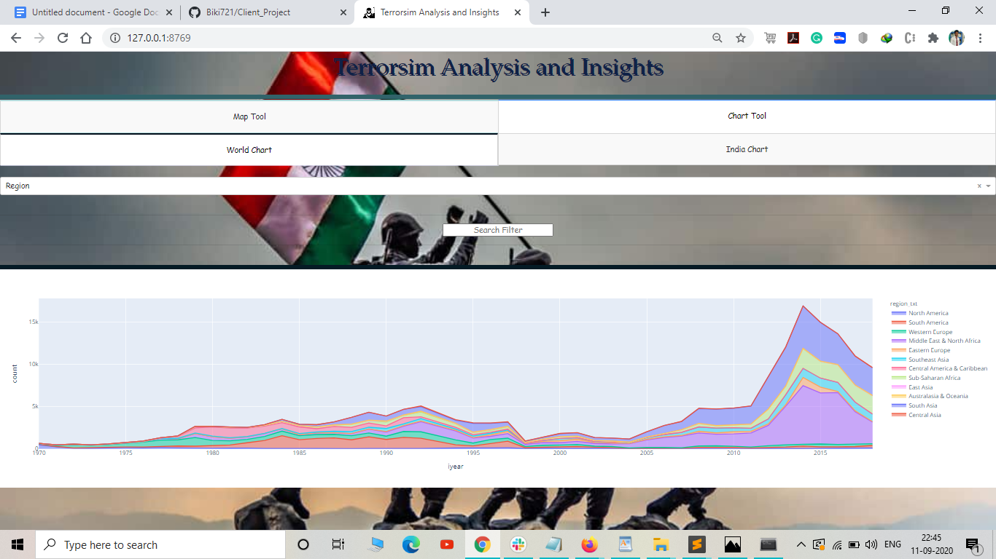

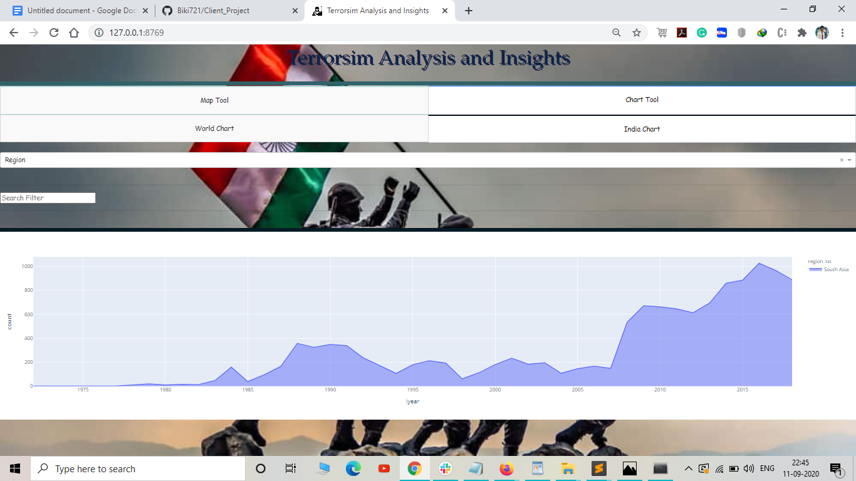

**Conclusion**

# 

* **Therefore, I conclude that developing a project with Forsk Technologies is an amazing journey.**
* **Working on this project with Forsk Technologies, I got a chance to get into a good developing community having kind & enthusiast developers. Here one can develop great research thinking & skills.**

# **Acknowledgements**

* ***I have successfully completed this project. However, it would not have been possible without the kind support and help of Forsk Technologies. I would like to extend my sincere thanks to Dr. Sylvester Fernandes sir and Mr. Yogendra Singh sir.***
* ***I am highly indebted to Dr. Sylvester Fernandes sir for their guidance and constant supervision as well as for providing necessary information regarding the project & also for their support in completing the project.***

# ***THANK YOU***

**References:**

**1. Forsk coding school**

**2. Plotly.com**

**3. W3school.com**

**4. Wikipedia**

**5. YouTube(for CSS)**

***Biography:***

I am BIKI DEY ,pursuing B.Tech degree in Computer Science and Engineering from Regional Institute Of Science and Technology,Meghalaya. My father is a Businessman and my mother is Home Maker. I aspire to become a Data Scientist. I have interest in web development too.